**Requirement Gathering and Analysis Phase**

**Data Flow Diagram & User Stories**

|  |  |
| --- | --- |
| Date | 27 June 2025 |
| Team ID | LTVIP2025TMID58382 |
| Project Name | Project – HouseHunt |

**Data Flow Diagrams:**

A Data Flow Diagram (DFD) is a traditional visual representation of the information flows within a system. A neat and clear DFD can depict the right amount of the system requirement graphically. It shows how data enters and leaves the system, what changes the information, and where data is stored.

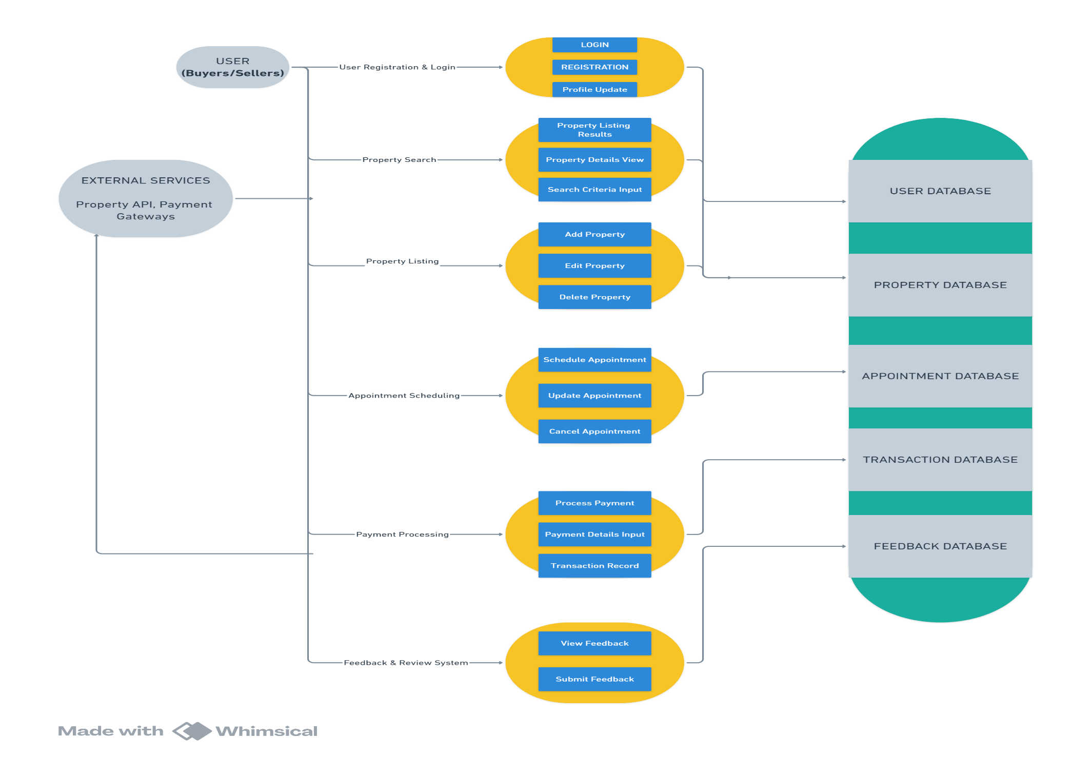

**User Stories**

Use the below template to list all the user stories for the product.

| **User Type** | **Functional Requirement (Epic)** | **User Story Number** | **User Story / Task** | **Acceptance criteria** | **Priority** | **Release** |
| --- | --- | --- | --- | --- | --- | --- |
| Customer (Web user) | Search and Filters | USN-1 | As a user, I want to search for properties by location, price range, and property type (apartments, villas, etc.) so I can find listings that meet my needs. | I can view properties based on my own specific needs | High | Sprint-1 |
| Customer (Mobile user) | User Accounts & Communication | USN-2 | **As a user, I want to create an account** through Gmail **with proper authentication and save my searches and favourite listings so I can easily access them later.** | I can access my account / dashboard | High | Sprint-1 |
| Customer (Mobile user) | User Accounts & Communication | USN-3 | As a user, I will receive confirmation email once I have registered for the application | I can receive confirmation email & click confirm | High | Sprint-1 |
| Customer (Web user) | Market Insights | USN-4 | **As a user, I want to see an indicator on listings of current and past price changes in the area.** | I can have an idea of monetary requirements and try to align my own assets with it | Low | Sprint-2 |
| Administrator | Environmental data | USN-5 | As a user, I want to see an overlay on listings showing estimated noise levels and air quality | I want to have an overview of the environmental factors | Low | Sprint-2 |
| Customer (Web user) | Detailed Listings | USN-6 | **As a user, I want to view detailed listings with high-quality photos and videos so I can get a good sense of the property.** | I can visually access and filter out properties | Medium | Sprint-1 |
| Customer (Web user) | User Accounts & Communication | USN-7 | As a user, I want to contact sellers or landlords directly through the platform to inquire about properties. | I can have one on one communication through this gateway | High | Sprint-1 |
| Administrator | Neighbourhood Insights | USN-8 | As a user, I want to have an idea about the surrounding neighbourhood, including schools, parks, and amenities. | I want an overview of the neighbourhood | High | Sprint-3 |
| Administrator | Community Rating, Reviews and Feedback | USN-9 | As a user, I want to read reviews from other users about neighbourhoods and property management companies. | Review and feedback | Medium | Sprint-2 |
| Customer (Web user) | School district & commute overlays | USN-10 | As a user, I want to filter listings based on commute time to specific locations (work, school). | Advanced filtering options | Low | Sprint-2 |
| Customer(Seller) | Dashboard for sellers, agents and landlords | USN-11 | **As a seller/landlord, I want to host a live, interactive open house directly on the platform, upload images, be able to directly communicate with clients and schedule meetings.** | I can market my properties | High | Sprint-3 |
| Administrator | Notifications | USN-12 | As a user, I want to be notified when new listings matching my saved searches become available. | notifications | High | Sprint-3 |
| Customer Care Executive | Security Considerations Enforcement | USN-13 | As a user, seller, dealer or landlord I want to deal with only legitimate and authorized individuals as well as property and want my own information to be secure. | Cyber security | High | Sprint-3 |